SOFTWARE REQUIREMENTS SPECIFICATION (SRS)

FOR

INVESTMENT MANAGEMENT MODULE

OF
ACCOUNTING AND PAYROLL SYSTEM (APS)

OF
INTEGRATED OFFICE MANAGEMENT SYSTEM OF RU

Version [1.1]

SOFTWARE REQUIREMENTS SPECIFICATION (SRS)
FOR

INVESTMENT MANAGEMENT MODULE

OF
ACCOUNTING AND PAYROLL SYSTEM (APS)

OF
INTEGRATED OFFICE MANAGEMENT SYSTEM OF RU

Approved: Accepted:

____________________________ _____________________________
[Project sponsor] date [Project Manager] date

Assured By:
___________________________
[SQA Manager] date

Table of contents
1 Purpose 6
2 Overview of the module 7
3 Functional Requirements – Scopes, Attributes & Use Cases 11
3.1 Manage Investment Proposal Information 11
3.1.1 Attribute List of ioms_RU/aps/IMM/sc/01 11
3.1.2 Use Cases 11
3.2 Manage FDR open Information 15
3.2.1 Attribute List of ioms_RU/aps/IMM/sc/02 15
3.2.2 Use Cases 17
3.3 Manage FDR Close Information 21
3.3.1 Attribute List of ioms_RU/aps/IMM/sc/03 21
3.3.2 Use Cases 22
3.4 Manage Purchase Bond Information 25
3.4.1 Attribute List of ioms_RU/aps/IMM/sc/04 25
3.4.2 Use Cases 27
3.5 Manage Sale Bond Information 31
3.5.1 Attribute List of ioms_RU/aps/IMM/sc/05 31
3.5.2 Use Cases 32
3.6 Generate Report 36
3.6.1 Use Cases 36
4 System requirements 41
4.1 Hardware: 41
4.2 Software: 42
5 Non-Functional Requirements 42
5.1 External Interfaces 42
5.2 System Message 42
6 Users 44
7 Appendix I – Glossary 44

List of Figures
Figure 1: Work Flow Diagram of Investment [Capital Fund] management 8
Figure 2: Use Case Diagram of Investment [Capital Fund] Management 9
Figure 3: Data Flow Diagram of Investment [Capital Fund] Management 10

Revision History
Date | Ver. | Description/Reason For Changes | Author | Reviewed By
Feb'03, 2013 | 1.0 | Initial Version | Arif Md. Abdus Shakur Chowdhury,  System Analyst
Feb 11,2013 | 1.1 | Revised Version:  All the scopes are reviewed with requirement provider . No feedback is received from external review session. | Arif Md. Abdus Shakur Chowdhury,  System Analyst | Mr. Afsar Ali, Deputy Director, Accounts

Purpose
University Automation Software is an initiative of Rajshahi University (RU) to provide an integrated system to connect different offices like VC/Pro-VC office, Treasures office, Registrar office, Accounts office, faculties and departments in a single window to secure exchange information's electronically.

Accounting and Payroll System (APS) is one of the major modules of University Automation Software of RU. Investment [capital fund] Management Module is sub module of AMS.

Investment Management:
This module will help accounts department and university authority to keep track of their invested amount. Also they could know about interest income any time they want. They could know upcoming maturity date of any FDR/Bond in no time. Relevant Accounts treatment also done automatically.

Benefits:
FDR/Bond information
Upcoming maturity information
Already matured and interest received register
Re-investment facility
Interest income forecasting
Auto accounting treatment
Save time and increase work efficiency

Overview of the module
Investment Management:
This Investment [Capital Fund] Management will manage all the FDR/Bond of the university. Capital Fund is the Universities own fund. University authority Invest those funds in different govt./commercial bank for generate income. Also they purchase govt. bonds for profit. At first AD,DD,FD and V.C together makes an informal meeting about the fund and how to invest where to invest. After decision the respective accounts officer will instructed to prepare a investment proposal file. AD,DD,FD and VC approve that file and send accounts department to issue the cheque in favor of selected bank. Then all information will go to FDR/Bond register and account officer will prepare voucher.
This module will keep all the information about FDR and Bonds. Also any time university authority can check the upcoming FDR/Bonds maturity date, so that they could forecast the interest income.
From this fund sometime university authority spend money for university development purpose. Also sometime takes loan from this fund in case of govt. budget allocation getting late. This kind of operation happen through accounts.

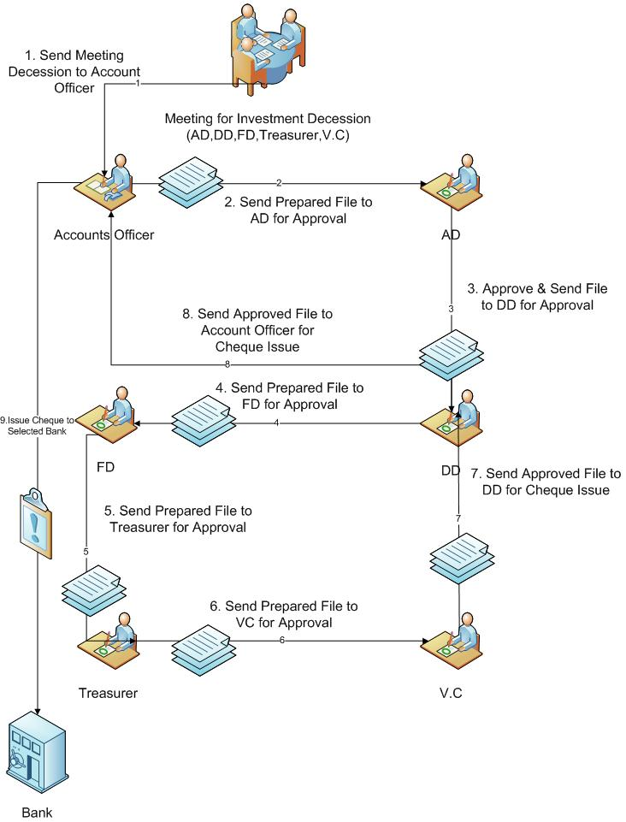

Figure 1: Work Flow Diagram of Investment [Capital Fund] management
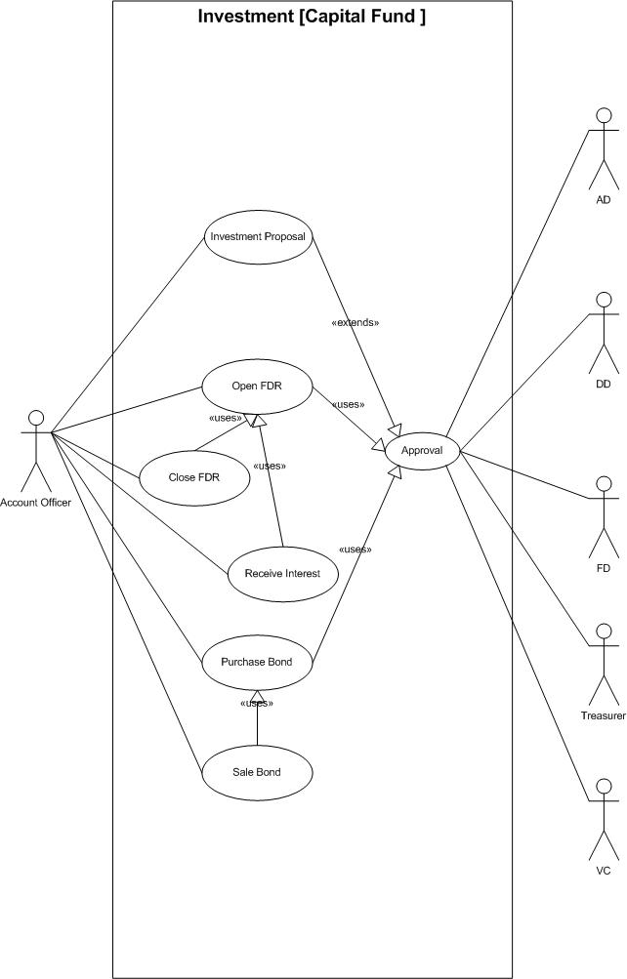
Figure 2: Use Case Diagram of Investment [Capital Fund] Management
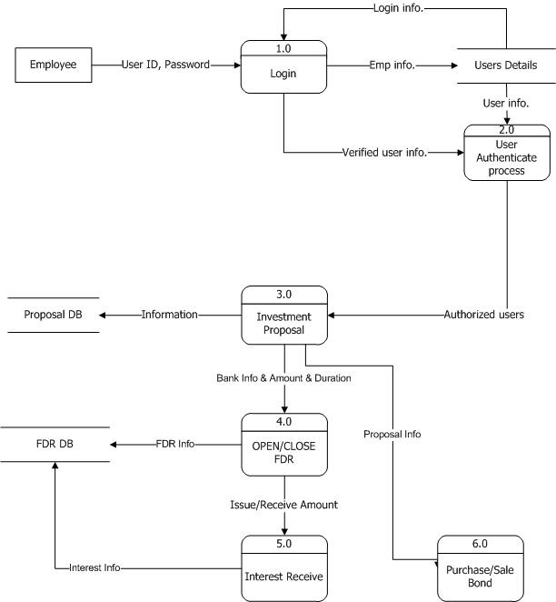
Figure 3: Data Flow Diagram of Investment [Capital Fund] Management

Functional Requirements – Scopes, Attributes & Use Cases

Manage Investment Proposal Information
1 | Scope ID | : | ioms_RU/aps/IMM/sc/01
General Description of Scope:
- This scope will manage all investment proposal information which will be used for FDR open and Bond Purchase

Attribute List of ioms_RU/aps/IMM/sc/01
Name of Attribute | Description | Field Size | Mandatory/  Optional | Language  (Bangla/English)
Proposal Code | Text;Generate | 5 | M | E
Proposal Date | DateTime; |  | M | E
Description | Text; | 300 | O | E
Investment Type | Text; derive from predefined List [FDR,Bond] | 10 | M | E
Proposed Investment Amount | Numeric | 10,2 | M | E
Proposed Bank | Text; Derive Bank list from Scope core acc module | 50 | M | E
Proposed Duration | Text; | 50 | O | E
Proposed Fund Source | Text; Derive list of Fund control from scope Core acc
Record Creator Name | Text | 100 | M | E
Record Creation Date | Date and Time |  | M | E
Record Modifier Name | Text | 100 | O | E
Record Modification Date | Date and Time |  | O | E

Use Cases

Add New Investment Proposal Information
Use Case ID: | ioms_RU/aps/IMM/sc/01-01
Use Case Description: | This use case describes the flows of storing Investment Proposal information into the system.
Actors: | Accounts Officer
Preconditions: | - Accounts Officer must be authorized user. Accounts Officer must be logged into the system.  - Accounts Officer must have "Add New" access privilege on Investment Proposal information.
Post conditions: | 1. System will store the information with generating a confirmation message.
Normal Flows | - Accounts Officer: Initiates to add new Investment Proposal information.  - System: Will show Investment Proposal entry page to add information.  - Accounts Officer: Will enter Investment Proposal and other related information and click on save button for saving required information.  - System:  - Will save the information  - Otherwise will generate alert message when  - Accounts Officer is failed to input mandatory information.  - Accounts Officer enters duplicate information
Alternative Flows: | N/A
Exceptions: | 3a. Accounts Officer: Cancels add new Investment Proposal information.  3b. System: Cancels add new Investment Proposal information.
Frequency of Use: | Low
Notes and Issues: | N/A
Cross References: | NA

Business Rule:
- N/A

View Investment Proposal Information
Use Case ID: | ioms_RU/aps/IMM/sc/01-02
Use Case Description: | This use case describes the flows of viewing Investment Proposal detail information in the system.
Actors: | Accounts Officer, AD, DD, FD, V.C
Preconditions: | - Actors must be authorized user. Actors must be logged into the system.  - Actors must have "View" access privilege on Investment Proposal information.  - Investment Proposal information must be existed in system. System shows all Investment Proposal information.
Post conditions: | - Accounts Officer can see detail information of selected Investment Proposal information in the system.
Normal Flows | - Actors: will initiate to view the existing Investment Proposal information.  - System: Will display Investment Proposal information page showing the available list of Investment Proposal information.  - Actors: Will choose the following parameter to find the desired information.  - Proposal Code  - Proposed Bank  - Investment Type  - System: Will display Investment Proposal information based on the selection criterion.
Alternative Flows: | N/A
Exceptions: | N/A
Frequency of Use: | Low
Notes and Issues: | N/A
Cross Reference: | NA

Business Rule:

N/A

Update Investment Proposal Information
Use Case ID: | ioms_RU/aps/IMM/sc/01-03
Use Case Description: | This use case describes the flows of updating of existing Investment Proposal information into the system.
Actors: | Accounts Officer
Preconditions: | - Accounts Officer must be authorized user. Accounts Officer must be logged into the system.  - Accounts Officer must have "Edit" access privilege on Investment Proposal information.  - Investment Proposal information must be existed in the system.
Post conditions: | - System will store the updated information and will generate a confirmation message
Normal Flows | - Accounts Officer: Will initiate and select the desired Investment Proposal information by using the use case ioms_RU/aps/IMM/sc/01-02.  - System: Will display Investment Proposal information of selected record in entry page.  - Accounts Officer: Will update the desired information and click on update button.  - System:  - Will save the information  - Otherwise will generate alert message when  - Accounts Officer is failed to input mandatory information.  - Accounts Officer enters duplicate information.
Alternative Flows: | N/A
Exceptions: | 3a. Accounts Officer: cancels update information.  3b. System: cancels update information.
Frequency of Use: | Low
Notes and Issues: | N/A
Cross Reference: | NA

Business Rule:
- If the data is already used in database, System will not update the data and will notify user with alert message.
- For updating information all business rule of ‘Add new’ will be applicable

Delete Investment Proposal Information
Use Case ID: | ioms_RU/aps/IMM/sc/01-04
Use Case Description: | This use case describes the flows of deleting of existing Investment Proposal information from system.
Actors: | Accounts Officer
Preconditions: | - Accounts Officer must be authorized user. Accounts Officer must be logged into the system.  - Accounts Officer must have "Delete" access privilege on Investment Proposal information.  - Investment Proposal information must have existed in system. System shows all Investment Proposal information.
Post conditions: | - Investment Proposal information will be deleted from the system and generate a confirmation message.
Normal Flows | - Accounts Officer: Will initiate and select the desired Investment Proposal information from the system by using the use case ioms_RU/aps/IMM/sc/01-02.  - System: Will generate a confirmation message showing “Yes” and “No” option.  - Accounts Officer: Click on either “Yes” or “No” option.  - System: if click on “Yes”, Will delete the information.
Alternative Flows: | N/A
Exceptions: | 3a. If Accounts Officer click on “No” option  System: Cancels the deletion.
Frequency of Use: | Low
Notes and Issues: | N/A
Cross Reference: | NA

Business Rule:
- Investment Proposal information cannot delete if it’s already used in any forward execution.

Manage FDR open Information
1 | Scope ID | : | ioms_RU/aps/IMM/sc/02
General Description of Scope:
- After getting all the approval on Investment proposal, Account Officer will open FDR.
- This scope will manage All information about FDR.

Attribute List of ioms_RU/aps/IMM/sc/02
Name of Attribute | Description | Field Size | Mandatory/  Optional | Language  (Bangla/English)
Code | Text;Generate; | 10 | M | E
Ref. Proposal Code | Text;Derive List of Investment Proposal from scope ioms_RU/aps/IMM/sc/01 where Investment Type=”FDR” | 5 | M | E
FDR No | Text; Unique | 20 | M | E
Bank Name | Text;Derive Bank name from scope ioms_RU/aps/IMM/sc/01 of selected proposal code | 10 | M | E
File No | Text | 10 | M | E
Approval Page No | Text | 10 | M | E
Investment Amount | Numeric; Derive from ioms_RU/aps/IMM/sc/01 of selected proposal code; Not editable | 10,2 | M | E
Open Date | DateTime; Derive from calendar tool |  | M | E
Maturity Date | DateTime; Derive from calendar tool |  | M | E
Interest Rate | Numeric | 10,2 | M | E
Receivable Interest | Numeric | 10,2 | M | E
Total Receivable Amount | Numeric; Investment Amount+Receivable Interest; Not editable | 10,2 | M | E
Bank Account No | Text; derive list of bank account from scope core account; Not editable | 20 | M | E
Cheque No | Text; | 20 | M | E
Cheque date | DateTime |  | M | E
Cheque signed by | text | 100 | O
Record Creator Name | Text | 100 | M | E
Record Creation Date | Date and Time |  | M | E
Record Modifier Name | Text | 100 | O | E
Record Modification Date | Date and Time |  | O | E

Use Cases

Add New FDR open information
Use Case ID: | ioms_RU/aps/IMM/sc/02-01
Use Case Description: | This use case describes the flows of storing FDR open information into the system.
Actors: | Accounts Officer
Preconditions: | - Accounts Officer must be authorized user. Accounts Officer must be logged into the system.  - Accounts Officer must have "Add New" access privilege on FDR open information.  - Derived information must be available in the system.
Post conditions: | 1. System will store the information with generating a confirmation message.
Normal Flows | - Accounts Officer: Initiates to add new FDR open information.  - System: Will show audit year entry page to add FDR open information.  - Accounts Officer: Will enter FDR open and other related information and click on save button for saving required information.  - System:  - Will save the information  - Otherwise will generate alert message when  - Accounts Officer is failed to input mandatory information.  - Accounts Officer enters duplicate information
Alternative Flows: | N/A
Exceptions: | 3a. Accounts Officer: Cancels add new FDR open information.  3b. System: Cancels add new FDR open information.
Frequency of Use: | Low
Notes and Issues: | N/A
Cross References: | NA

Business Rule:
- FDR no is Unique

View Types of FDR open Information
Use Case ID: | ioms_RU/aps/IMM/sc/02-02
Use Case Description: | This use case describes the flows of viewing FDR open detail information in the system.
Actors: | Accounts Officer
Preconditions: | - Accounts Officer must be authorized user. Accounts Officer must be logged into the system.  - Accounts Officer must have "View" access privilege on FDR open information.  - FDR open information must be existed in system. System shows all FDR open information.
Post conditions: | - Accounts Officer can see detail information of selected FDR open information in the system.
Normal Flows | - Accounts Officer: will initiate to view the existing FDR open information.  - System: Will display FDR open information page showing the available list of FDR open information.  - Accounts Officer: Will choose the following parameter to find the desired information.  - FDR no  - Investment proposal code  - Cheque no  - Open date  - Maturity date  - System: Will display FDR open information based on the selection criterion.
Alternative Flows: | N/A
Exceptions: | N/A
Frequency of Use: | Low
Notes and Issues: | N/A
Cross Reference: | NA

Business Rule:

N/A

Update FDR open Information
Use Case ID: | ioms_RU/aps/IMM/uc/02-03
Use Case Description: | This use case describes the flows of updating of existing FDR open information into the system.
Actors: | Accounts Officer
Preconditions: | - Accounts Officer must be authorized user. Accounts Officer must be logged into the system.  - Accounts Officer must have "Edit" access privilege on FDR open information.  - FDR open information must be existed in the system.
Post conditions: | - System will store the updated information and will generate a confirmation message
Normal Flows | - Accounts Officer: Will initiate and select the desired FDR open information by using the use case ioms_RU/aps/IMM/sc/02-02.  - System: Will display FDR open information of selected record in entry page.  - Accounts Officer: Will update the desired information and click on update button.  - System:  - Will save the information  - Otherwise will generate alert message when  - Accounts Officer is failed to input mandatory information.  - Accounts Officer enters duplicate information.
Alternative Flows: | N/A
Exceptions: | 3a. Accounts Officer: cancels update information.  3b. System: cancels update information.
Frequency of Use: | Low
Notes and Issues: | N/A
Cross Reference: | NA

Business Rule:
- For updating information all business rule of ‘Add new’ will be applicable

Delete FDR open Information
Use Case ID: | ioms_RU/aps/IMM/uc/02-04
Use Case Description: | This use case describes the flows of deleting of existing FDR open information from system.
Actors: | Accounts Officer
Preconditions: | - Accounts Officer must be authorized user. Accounts Officer must be logged into the system.  - Accounts Officer must have "Delete" access privilege on FDR open information.  - FDR open information must have existed in system. System shows all FDR open information.
Post conditions: | - FDR open information will be deleted from the system and generate a confirmation message.
Normal Flows | - Accounts Officer: Will initiate and select the desired FDR open information from the system by using the use case ioms_RU/aps/IMM/sc/02-02.  - System: Will generate a confirmation message showing “Yes” and “No” option.  - Accounts Officer: Click on either “Yes” or “No” option.  - System: if click on “Yes”, Will delete the information.
Alternative Flows: | N/A
Exceptions: | 3a. If Accounts Officer click on “No” option  System: Cancels the deletion.  3b. System: Cancels the deletion and display the dependency message.
Frequency of Use: | Low
Notes and Issues: | N/A
Cross Reference: | NA

Business Rule:
- FDR open information cannot delete if it’s already used in any forward execution.

Manage FDR Close Information
1 | Scope ID | : | ioms_RU/aps/IMMm/sc/03
General Description of Scope:
- Accounts Officer Close the FDR when it is matured.
- Also receive the interest.

Attribute List of ioms_RU/aps/IMM/sc/03
Name of Attribute | Description | Field Size | Mandatory/  Optional | Language  (Bangla/English)
FDR No | Text; Derive FDR list from scope ioms_RU/aps/IMM/sc/02; | 20 | M | E
Closing Date | DateTime |  | M | E
FDR Amount | Numeric; Derive from scope ioms_RU/aps/IMM/sc/02 of selected FDR | 10,2 | M | E
Interest Received | Numeric; Derive from scope ioms_RU/aps/IMM/sc/02 of selected FDR; Editable because sometime interest changes after maturity | 10,2 | M | E
Bank Account | Text; Derive list of bank acc from Core Acc | 50 | M | E
File no | Text; | 10 | M | E
Page No | Text | 10 | M | E
Remarks | Text | 300 | O | B
Fund Control | Text; derive scope ioms_RU/aps/CACC/sc/01 | 50 | M
Account Head [Interest received] | Text; derive ioms_RU/aps/CACC/sc/05 | 50 | M
Record Creator Name | Text | 100 | M | E
Record Creation Date | Date and Time |  | M | E
Record Modifier Name | Text | 100 | O | E
Record Modification Date | Date and Time |  | O | E

Use Cases

Add New FDR Close information
Use Case ID: | ioms_RU/aps/IMM/sc/03-01
Use Case Description: | This use case describes the flows of storing FDR Close information into the system.
Actors: | Accounts Officer
Preconditions: | - Accounts Officer must be authorized user. Accounts Officer must be logged into the system.  - Accounts Officer must have "Add New" access privilege on FDR Close information.  - Derived information must be available in the system.
Post conditions: | 1. System will store the information with generating a confirmation message.
Normal Flows | - Accounts Officer: Initiates to add new FDR Close information.  - System: Will show FDR Close entry page to add FDR Close information.  - Accounts Officer: Will enter FDR Close and other related information and click on save button for saving required information.  - System:  - Will save the information  - Otherwise will generate alert message when  - Accounts Officer is failed to input mandatory information.  - Accounts Officer enters duplicate information
Alternative Flows: | N/A
Exceptions: | 3a. Accounts Officer: Cancels add new FDR Close information.  3b. System: Cancels add new FDR Close information.
Frequency of Use: | Low
Notes and Issues: | N/A
Cross References: | NA

Business Rule:
- n/a

View FDR Close Information
Use Case ID: | ioms_RU/aps/IMM/sc/03-02
Use Case Description: | This use case describes the flows of viewing FDR Close detail information in the system.
Actors: | Accounts Officer
Preconditions: | - Accounts Officer must be authorized user. Accounts Officer must be logged into the system.  - Accounts Officer must have "View" access privilege on FDR Close information.  - FDR Close information must be existed in system. System shows all FDR Close information.
Post conditions: | - Accounts Officer can see detail information of selected FDR Close information in the system.
Normal Flows | - Accounts Officer: will initiate to view the existing FDR Close information.  - System: Will display FDR Close information page showing the available list of FDR Close information.  - Accounts Officer: Will choose the following parameter to find the desired information.  - FDR No  - Maturity date  - Closing Date  - System: Will display FDR Close information based on the selection criterion.
Alternative Flows: | N/A
Exceptions: | N/A
Frequency of Use: | Low
Notes and Issues: | N/A
Cross Reference: | NA

Business Rule:

N/A

Update FDR Close Information
Use Case ID: | ioms_RU/aps/IMM/sc/03-03
Use Case Description: | This use case describes the flows of updating of existing FDR Close information into the system.
Actors: | Accounts Officer
Preconditions: | - Accounts Officer must be authorized user. Accounts Officer must be logged into the system.  - Accounts Officer must have "Edit" access privilege on FDR Close information.  - FDR Close information must be existed in the system.
Post conditions: | - System will store the updated information and will generate a confirmation message
Normal Flows | - Accounts Officer: Will initiate and select the desired FDR Close information by using the use case ioms_RU/aps/IMM/sc/03-02.  - System: Will display FDR Close information of selected record in entry page.  - Accounts Officer: Will update the desired information and click on update button.  - System:  - Will save the information  - Otherwise will generate alert message when  - Account officer is failed to input mandatory information.  - Account officer enters duplicate information.
Alternative Flows: | N/A
Exceptions: | 3a. Accounts Officer: cancels update information.  3b. System: cancels update information.
Frequency of Use: | Low
Notes and Issues: | N/A
Cross Reference: | NA

Business Rule:
- n/a

Delete FDR Close Information
Use Case ID: | ioms_RU/aps/IMM/sc/03-04
Use Case Description: | This use case describes the flows of deleting of existing FDR Close information from system.
Actors: | Accounts Officer
Preconditions: | - Accounts Officer must be authorized user. FDR Close must be logged into the system.  - Accounts Officer must have "Delete" access privilege on FDR Close information.  - FDR Close information must have existed in system. System shows all FDR Close information.
Post conditions: | - FDR Close information will be deleted from the system and generate a confirmation message.
Normal Flows | - Accounts Officer: Will initiate and select the desired FDR Close information from the system by using the use case ioms_RU/aps/IMM/sc/03-02.  - System: Will generate a confirmation message showing “Yes” and “No” option.  - Accounts Officer: Click on either “Yes” or “No” option.  - System: if click on “Yes”, Will delete the information.
Alternative Flows: | N/A
Exceptions: | 3a. If Accounts Officer click on “No” option  System: Cancels the deletion.  3b. If parent-child relation exists  3b1 System: Cancels the deletion and display the dependency message.
Frequency of Use: | Low
Notes and Issues: | N/A
Cross Reference: | NA

Business Rule:
- FDR Close information cannot delete if it’s already used in any forward execution.

Manage Purchase Bond Information
1 | Scope ID | : | ioms_RU/aps/IMM/sc/04
General Description of Scope:
- After getting all the approval on Investment proposal, Account Officer will purchase bond.
- This scope will manage All information about bond.

Attribute List of ioms_RU/aps/IMM/sc/04
Name of Attribute | Description | Field Size | Mandatory/  Optional | Language  (Bangla/English)
Code | Text;Generate; | 10 | M | E
Ref. Proposal Code | Text;Derive List of Investment Proposal from scope ioms_RU/aps/IMM/sc/01 where Investment Type=”Bond” | 5 | M | E
Bond No | Text; Unique | 20 | M | E
Bank Name | Text;Derive Bank name from scope ioms_RU/aps/IMM/sc/01 of selected proposal code | 10 | M | E
File No | Text | 10 | M | E
Approval Page No | Text | 10 | M | E
Investment Amount | Numeric; Derive from ioms_RU/aps/IMM/sc/01 of selected proposal code; Not editable | 10,2 | M | E
Purchase Date | DateTime; Derive from calendar tool |  | M | E
Maturity Date | DateTime; Derive from calendar tool |  | M | E
Interest Rate | Numeric | 10,2 | M | E
Receivable Interest | Numeric | 10,2 | M | E
Total Receivable Amount | Numeric; Investment Amount+Receivable Interest; Not editable | 10,2 | M | E
Bank Account No | Text; derive list of bank account from scope core account; Not editable | 20 | M | E
Cheque No | Text; | 20 | M | E
Cheque date | DateTime |  | M | E
Cheque signed by | Text; | 100 | O | E
Record Creator Name | Text | 100 | M | E
Record Creation Date | Date and Time |  | M | E
Record Modifier Name | Text | 100 | O | E
Record Modification Date | Date and Time |  | O | E

Use Cases

Add New Purchase Bond information
Use Case ID: | ioms_RU/aps/IMM/sc/04-01
Use Case Description: | This use case describes the flows of storing Purchase Bond information into the system.
Actors: | Accounts Officer
Preconditions: | - Accounts Officer must be authorized user. Accounts Officer must be logged into the system.  - Accounts Officer must have "Add New" access privilege on Purchase Bond information.  - Derived information must be available in the system.
Post conditions: | 1. System will store the information with generating a confirmation message.
Normal Flows | - Accounts Officer: Initiates to add new Purchase Bond information.  - System: Will show audit year entry page to add Purchase Bond information.  - Accounts Officer: Will enter Purchase Bond and other related information and click on save button for saving required information.  - System:  - Will save the information  - Otherwise will generate alert message when  - Accounts Officer is failed to input mandatory information.  - Accounts Officer enters duplicate information
Alternative Flows: | N/A
Exceptions: | 3a. Accounts Officer: Cancels add new Purchase Bond information.  3b. System: Cancels add new Purchase Bond information.
Frequency of Use: | Low
Notes and Issues: | N/A
Cross References: | NA

Business Rule:
- Bond no is Unique

View Types of Purchase Bond Information
Use Case ID: | ioms_RU/aps/IMM/sc/04-02
Use Case Description: | This use case describes the flows of viewing Purchase Bond detail information in the system.
Actors: | Accounts Officer
Preconditions: | - Accounts Officer must be authorized user. Accounts Officer must be logged into the system.  - Accounts Officer must have "View" access privilege on Purchase Bond information.  - FDR open information must be existed in system. System shows all Purchase Bond information.
Post conditions: | - Accounts Officer can see detail information of selected Purchase Bond information in the system.
Normal Flows | - Accounts Officer: will initiate to view the existing Purchase Bond information.  - System: Will display Purchase Bond information page showing the available list of Purchase Bond information.  - Accounts Officer: Will choose the following parameter to find the desired information.  - Bond no  - Investment proposal code  - Cheque no  - Open date  - Maturity date  - System: Will display Purchase Bond information based on the selection criterion.
Alternative Flows: | N/A
Exceptions: | N/A
Frequency of Use: | Low
Notes and Issues: | N/A
Cross Reference: | NA

Business Rule:

N/A

Update Purchase Bond Information
Use Case ID: | ioms_RU/aps/IMM/sc/04-03
Use Case Description: | This use case describes the flows of updating of existing Purchase Bond information into the system.
Actors: | Accounts Officer
Preconditions: | - Accounts Officer must be authorized user. Accounts Officer must be logged into the system.  - Accounts Officer must have "Edit" access privilege on Purchase Bond information.  - Purchase Bond information must be existed in the system.
Post conditions: | - System will store the updated information and will generate a confirmation message
Normal Flows | - Accounts Officer: Will initiate and select the desired Purchase Bond information by using the use case ioms_RU/aps/IMM/sc/04-02.  - System: Will display Purchase Bond information of selected record in entry page.  - Accounts Officer: Will update the desired information and click on update button.  - System:  - Will save the information  - Otherwise will generate alert message when  - Accounts Officer is failed to input mandatory information.  - Accounts Officer enters duplicate information.
Alternative Flows: | N/A
Exceptions: | 3a. Accounts Officer: cancels update information.  3b. System: cancels update information.
Frequency of Use: | Low
Notes and Issues: | N/A
Cross Reference: | NA

Business Rule:
- For updating information all business rule of ‘Add new’ will be applicable

Delete Purchase Bond Information
Use Case ID: | ioms_RU/aps/IMM/sc/04-04
Use Case Description: | This use case describes the flows of deleting of existing Purchase Bond information from system.
Actors: | Accounts Officer
Preconditions: | - Accounts Officer must be authorized user. Accounts Officer must be logged into the system.  - Accounts Officer must have "Delete" access privilege on Purchase Bond information.  - Purchase Bond information must have existed in system. System shows all Purchase Bond information.
Post conditions: | - Purchase Bond information will be deleted from the system and generate a confirmation message.
Normal Flows | - Accounts Officer: Will initiate and select the desired Purchase Bond information from the system by using the use case ioms_RU/aps/IMM/sc/04-02.  - System: Will generate a confirmation message showing “Yes” and “No” option.  - Accounts Officer: Click on either “Yes” or “No” option.  - System: if click on “Yes”, Will delete the information.
Alternative Flows: | N/A
Exceptions: | 3a. If Accounts Officer click on “No” option  System: Cancels the deletion.  3b. System: Cancels the deletion and display the dependency message.
Frequency of Use: | Low
Notes and Issues: | N/A
Cross Reference: | NA

Business Rule:
- Purchase Bond information cannot delete if it’s already used in any forward execution.

Manage Sale Bond Information
1 | Scope ID | : | ioms_RU/aps/IMM/sc/05
General Description of Scope:
- Accounts Officer Sale Bond when it is matured.
- Also receive the interest.

Attribute List of ioms_RU/aps/IMM/sc/05
Name of Attribute | Description | Field Size | Mandatory/  Optional | Language  (Bangla/English)
Bond No | Text; Derive Bond list from scope ioms_RU/aps/IMM/sc/04; | 20 | M | E
Sale Date | DateTime |  | M | E
Bond Amount | Numeric; Derive from scope ioms_RU/aps/IMM/sc/04 of selected Bond | 10,2 | M | E
Interest Received | Numeric; Derive from scope ioms_RU/aps/IMM/sc/04 of selected Bond; Editable because sometime interest changes after maturity | 10,2 | M | E
Bank Account | Text; Derive list of bank acc from Core Acc | 50 | M | E
File no | Text; | 10 | M | E
Page No | Text | 10 | M | E
Fund Control | Text; derive scope ioms_RU/aps/CACC/sc/01
Account Head [Interest received] | Text; derive ioms_RU/aps/CACC/sc/05
Remarks | Text | 300 | O | B
Record Creator Name | Text | 100 | M | E
Record Creation Date | Date and Time |  | M | E
Record Modifier Name | Text | 100 | O | E
Record Modification Date | Date and Time |  | O | E

Use Cases

Add New Sale Bond information
Use Case ID: | ioms_RU/aps/IMM/sc/05-01
Use Case Description: | This use case describes the flows of storing Sale Bond information into the system.
Actors: | Accounts Officer
Preconditions: | - Accounts Officer must be authorized user. Accounts Officer must be logged into the system.  - Accounts Officer must have "Add New" access privilege on Sale Bond information.  - Derived information must be available in the system.
Post conditions: | 1. System will store the information with generating a confirmation message.
Normal Flows | - Accounts Officer: Initiates to add new Sale Bond information.  - System: Will show Sale Bond entry page to add Sale Bond information.  - Accounts Officer: Will enter Sale Bond and other related information and click on save button for saving required information.  - System:  - Will save the information  - Otherwise will generate alert message when  - Accounts Officer is failed to input mandatory information.  - Accounts Officer enters duplicate information
Alternative Flows: | N/A
Exceptions: | 3a. Accounts Officer: Cancels add new Sale Bond information.  3b. System: Cancels add new Sale Bond information.
Frequency of Use: | Low
Notes and Issues: | N/A
Cross References: | NA

Business Rule:
- n/a

View Sale Bond Information
Use Case ID: | ioms_RU/aps/IMM/sc/05-02
Use Case Description: | This use case describes the flows of viewing Sale Bond detail information in the system.
Actors: | Accounts Officer
Preconditions: | - Accounts Officer must be authorized user. Accounts Officer must be logged into the system.  - Accounts Officer must have "View" access privilege on Sale Bond information.  - Sale Bond information must be existed in system. System shows all Sale Bond information.
Post conditions: | - Accounts Officer can see detail information of selected Sale Bond information in the system.
Normal Flows | - Accounts Officer: will initiate to view the existing Sale Bond information.  - System: Will display Sale Bond information page showing the available list of Sale Bond information.  - Accounts Officer: Will choose the following parameter to find the desired information.  - Bond No  - Maturity date  - Closing Date  - System: Will display Sale Bond information based on the selection criterion.
Alternative Flows: | N/A
Exceptions: | N/A
Frequency of Use: | Low
Notes and Issues: | N/A
Cross Reference: | NA

Business Rule:

N/A

Update Sale Bond Information
Use Case ID: | ioms_RU/aps/IMM/sc/05-03
Use Case Description: | This use case describes the flows of updating of existing Sale Bond information into the system.
Actors: | Accounts Officer
Preconditions: | - Accounts Officer must be authorized user. Accounts Officer must be logged into the system.  - Accounts Officer must have "Edit" access privilege on Sale Bond information.  - Sale Bond information must be existed in the system.
Post conditions: | - System will store the updated information and will generate a confirmation message
Normal Flows | - Accounts Officer: Will initiate and select the desired Sale Bond information by using the use case ioms_RU/aps/IMM/sc/05-02.  - System: Will display Sale Bond information of selected record in entry page.  - Accounts Officer: Will update the desired information and click on update button.  - System:  - Will save the information  - Otherwise will generate alert message when  - Account officer is failed to input mandatory information.  - Account officer enters duplicate information.
Alternative Flows: | N/A
Exceptions: | 3a. Accounts Officer: cancels update information.  3b. System: cancels update information.
Frequency of Use: | Low
Notes and Issues: | N/A
Cross Reference: | NA

Business Rule:
- n/a

Delete Sale Bond Information
Use Case ID: | ioms_RU/aps/IMM/sc/05-04
Use Case Description: | This use case describes the flows of deleting of existing Sale Bond information from system.
Actors: | Accounts Officer
Preconditions: | - Accounts Officer must be authorized user. Sale Bond must be logged into the system.  - Accounts Officer must have "Delete" access privilege on Sale Bond information.  - Sale Bond information must have existed in system. System shows all Sale Bond information.
Post conditions: | - Sale Bond information will be deleted from the system and generate a confirmation message.
Normal Flows | - Accounts Officer: Will initiate and select the desired Sale Bond information from the system by using the use case ioms_RU/aps/IMM/sc/05-02.  - System: Will generate a confirmation message showing “Yes” and “No” option.  - Accounts Officer: Click on either “Yes” or “No” option.  - System: if click on “Yes”, Will delete the information.
Alternative Flows: | N/A
Exceptions: | 3a. If Accounts Officer click on “No” option  System: Cancels the deletion.  3b. If parent-child relation exists  3b1 System: Cancels the deletion and display the dependency message.
Frequency of Use: | Low
Notes and Issues: | N/A
Cross Reference: | NA

Business Rule:
- Sale Bond information cannot delete if it’s already used in any forward execution.

Generate Report
Table 1: Reports
Use Case ID | Report Name
ioms_RU/aps/IMM/sc/06-01 | FDR Register
ioms_RU/aps/IMM/sc/06-02 | Bond Register

Use Cases

Generate FDR Register
Use Case ID: | ioms_RU/aps/IMM/sc/06-01
Use Case Description: | This use case describes the flows of generating FDR register.
Actors: | Authorized User
Preconditions: | - User must be authorized user and logged into the system.  - User must have "Preview" access privilege on FDR register report.
Post conditions: | - Depending on the parameter(s), system will generate the report.
Normal Flows | - User: will initiate to generate report of FDR register.  - System: will display the report parameter page and populate list information in the respective dropdown list.  - User: will provide the following parameters to generate the report.  - Fund Control  - FDR no  - Bank Name  - Account No  - Maturity from date  - Maturity to date  - FDR open from date  - FDR open to date  - System: will generate a validation message when  - User is failed to input mandatory parameter.  - User: will click on preview button.  - System: will generate a report with following information.  - Fund Control  - Account No  - SL  - Bank Name  - FDR no  - Amount  - Open date  - Maturity Date  - Duration  - Interest rate  - Total Interest  - Total Amount  - Investment Proposal No
Alternative Flows: | N/A
Exceptions: | 4a1 System: Cancels preview the report and generate a message.  6a. If data is not found then  System: will generate report without information.
Frequency of Use: | Low
Notes and Issues:

UI Guideline

Report Title: FDR Register Report
Report Format:
Fund Control
Account No

SL | Bank Name | FDR No | Amount |  | Open Date |  | Maturity Date | Duration (in month) | Interest Rate | Total Interest | Total Amount | Investment Proposal No
1 | Prime | ab 45 | 1000000 |  | 12/11/2012 |  | 12/11/2013 | 12 | 12.5 | 125000 | 1125000 | 3
2 | Sonali | cd 65 | 2000000 |  | 30/10/2011 |  | 30/10/2012 | 12 | 10.5 | 210000 | 2210000 | 2
Total Amount:

Business Rule
- Search Criteria:
- Fund Control : Mandatory;
- FDR no: Optional;
- Bank Name: Optional
- Account No: Optional
- Maturity from date: Optional
- Maturity to date: Optional
- FDR open from date : Optional
- FDR open to date: Optional

- Report Information:
- Fund Control: Derived from Ref. Scope Fund Control of Core Acc
- FDR no: Derived from Ref. Scope ioms_RU/aps/IMM/sc/02 filter by selected fund control
- Bank Name: Derived from Ref. Scope ioms_RU/aps/IMM/sc/02 filter by selected fund control
- Account No: Derived from Ref. Scope ioms_RU/aps/IMM/sc/02 filter by selected fund control
- Maturity from date: calendar tool
- Maturity to date: calendar tool
- FDR open from date: calendar tool
- FDR open to date : calendar tool

- Order By FDR open Date
- Group By Fund control & combination of parameter selection criteria
- Already Matured/Closed FDR will show in colored row

Generate Bond Register
Use Case ID: | ioms_RU/aps/IMM/sc/06-02
Use Case Description: | This use case describes the flows of generating Bond register.
Actors: | Authorized User
Preconditions: | - User must be authorized user and logged into the system.  - User must have "Preview" access privilege on Bond register report.
Post conditions: | - Depending on the parameter(s), system will generate the report.
Normal Flows | - User: will initiate to generate report of Bond register.  - System: will display the report parameter page and populate list information in the respective dropdown list.  - User: will provide the following parameters to generate the report.  - Fund Control  - Bond no  - Bank Name  - Account No  - Bond sale from date  - Bond sale to date  - Bond Purchase from date  - FDR Purchase to date  - System: will generate a validation message when  - User is failed to input mandatory parameter.  - User: will click on preview button.  - System: will generate a report with following information.  - Fund Control  - Account No  - SL  - Bank Name  - Bond no  - Amount  - Purchase date  - Sale Date  - Duration  - Interest rate  - Total Interest  - Total Amount  - Investment Proposal No
Alternative Flows: | N/A
Exceptions: | 4a1 System: Cancels preview the report and generate a message.  4a. If data is not found then  System: will generate report without information.
Frequency of Use: | Low
Notes and Issues:

UI Guideline

Report Title: Bond Register Report
Report Format:
Fund Control
Account No

SL | Bank Name | Bond No | Amount |  | Purchase Date |  | Sale Date | Duration (in month) | Interest Rate | Total Interest | Total Amount | Investment Proposal No
1 | Prime | ab 45 | 1000000 |  | 12/11/2012 |  | 12/11/2013 | 12 | 12.5 | 125000 | 1125000 | 3
2 | Sonali | cd 65 | 2000000 |  | 30/10/2011 |  | 30/10/2012 | 12 | 10.5 | 210000 | 2210000 | 2
Total Amount:

Business Rule
- Search Criteria:
- Fund Control : Mandatory;
- Bond no: Optional;
- Bank Name: Optional
- Account No: Optional
- Sale from date: Optional
- Sale to date: Optional
- Purchase from date : Optional
- Purchase to date: Optional

- Report Information:
- Fund Control: Derived from Ref. Scope Fund Control of Core Acc
- Bond no: Derived from Ref. Scope ioms_RU/aps/IMM/sc/04 filter by selected fund control
- Bank Name: Derived from Ref. Scope ioms_RU/aps/IMM/sc/04 filter by selected fund control
- Account No: Derived from Ref. Scope ioms_RU/aps/IMM/sc/04 filter by selected fund control
- sale from date: calendar tool
- Sale to date: calendar tool
- Purchase from date: calendar tool
- Purchase to date : calendar tool

- Order By Purchase Date
- Group By Fund control & combination of parameter selection criteria
- Already Sold Bond will show in colored row

System requirements

Hardware:
Minimum Requirements for client PC:
SL. | Description | Specification
1 | Processor | Intel Pentium Dual Core 2.6Ghz E5300
2 | Mother Board | Gigabyte Intel G31 Chipset G41M-Es2L
3 | Hard Disk Drive | Samsung 160 Gb Sata
4 | Sound Card | On board 8 Channel
5 | LAN | On-board 10/100 MBPS
6 | RAM | 1 GB DDR 800 bus
7 | Mouse | A4 Tech Optical
8 | Keyboard | Keyboard Kbs-720
9 | Monitor | Samsung 17 Inch Wide Lcd Monitor
10 | Casing | Delux 432 ATX Casing

Software:
Minimum Requirements of Client side:
SL. | Type of Software | Software Description | Version
 | Operating System (OS) | Windows XP Professional/ Windows Vista / Windows 7
 | Browser | Internet explorer (IE)  Mozilla Firefox  Safari  Google Chrome  Opera | 8+  3.6+  5.0+
 | Others | Microsoft Office | 2007

Minimum Requirements of Server side:
SL. | Type of Software | Software Description | Version
 | Operating System (OS) | Server Independent | -
 | Reporting Tool | JasperReports | 4.7.0
 | Database | MySQL | 5.5
 | Framework | J2EE, Spring
 | Web Server | Apache
 | Browser | Internet explorer (IE)  Mozilla Firefox  Safari  Google Chrome  Opera | 8+  3.6+  5.0+
 | Mail Transfer Protocol | Simple Mail Transfer Protocol (SMTP) | 1.5+
 | Others | Microsoft Office | 2007

Non-Functional Requirements

External Interfaces
- Administrative Office Automation (AOA) System.

System Message
Message window
For successfully save record | 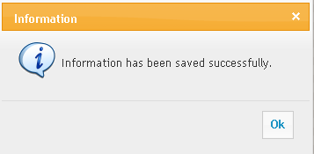
For successfully delete record | 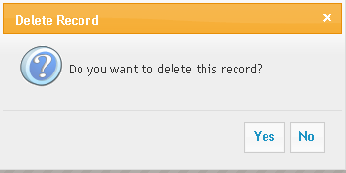
For mandatory fields | 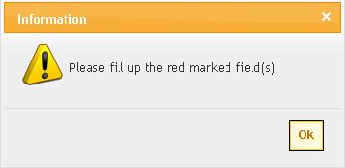

# | Item | Message
 | Successful Add Update | Information has been saved successfully.
 | Unsuccessful Add Update | Cannot save the information. Please try again.
 | Successful Delete | Information has been deleted successfully.
 | Unsuccessful Delete | Information can not be deleted due to dependency.
 | Blank Mandatory Field | Please provide the following information
 | Server Error | Cannot perform the operation.

Users
This document will be used by following users of the system

- Finance Director
- Deputy Director, Accounts
- Assistant Director, Accounts
- Accounts Officer

Appendix I – Glossary
Definition, Acronyms and Terminology
SL No. | Abbreviation | Description /Expansion
1 | RU | Rajshahi University
2 | FD | Finance Director
3 | DD | Deputy Director

